WURZENBERG

The luxury of stillness.

PRESS FACT SHEET · 2026

A place shaped by Panorama Therapy®,
high above the vineyards of Southern Styria
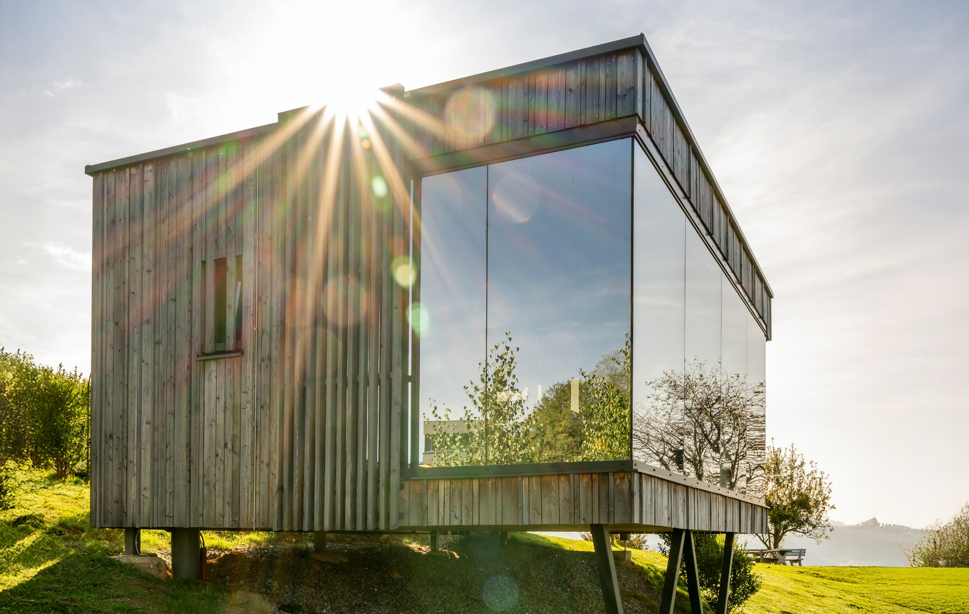

ABOUT WURZENBERG
High above the vineyards of Southern Styria lies Wurzenberg.
Today, it is a place for stillness, openness and retreat — shaped by landscape, architecture and a deliberate reduction to what matters.
A few houses.
A few lodges.
Expansive glass fronts.
And surroundings that become part of the stay.
At Wurzenberg, luxury is not defined by abundance.
But by space.
A place where stillness finds space.

AT A GLANCE
Name | Wurzenberg
Location | Sernauberg · Leutschach an der Weinstraße · Styria · Austria
Region | Nature Park South Styrian Wine Country
Hosts | The Lippnegg family
Concept | Panorama Therapy® · stillness · openness · intentional simplicity
Accommodation | Houses · Mispellodges · Traditional Lodges · Panorama Rooms
Breakfast | Pyjama Breakfast® delivered directly to the accommodation
Wellbeing | Private panorama sauna
Sustainability | Solar energy · solid timber construction · local producers
Mobility | EV charging stations · e-bike infrastructure
Website | wurzenberg.at

THE PHILOSOPHY
Wurzenberg was created as a deliberate counterpoint to:
— constant availability
— overstimulation
— crowded itineraries
— traditional hotel routines
At its centre:

Stillness.

Openness.
Simplicity.
A stay follows no fixed programme.
Only your own rhythm.

PANORAMA THERAPY®
Panorama Therapy® describes the interaction between:
architecture
landscape
light
stillness
and openness
The outward view becomes part of the experience.
Fewer impressions.
More clarity.

THE PLACE
Wurzenberg is situated in a secluded setting at Sernauberg — high above the vineyards of Southern Styria.
The location shapes nearly every stay:
Morning light over rolling hills.
Silence between vineyards.
Expansive views stretching into the distance.
A place that does not need to be loud to leave an impression.

ARCHITECTURE
Architecture at Wurzenberg is not created for spectacle.
Large glass surfaces, reduced materials and solid timber construction deliberately open the view outward.
Many accommodations remain intentionally understated, with focus on:
— privacy
— light
— stillness
— landscape
— openness
Architecture becomes not a statement.
More of a frame.

STAYING AT WURZENBERG

Houses
Freestanding lodges in secluded settings with maximum privacy.
Rosenlodge
Thymianlodge

Mispellodges
Contemporary panorama lodges with different orientations:
Mispellodge 140°
Mispellodge 180°
Mispellodge 270°

Traditional Lodges
Characterful retreats within the historic part of the house:
Birkenlodge
Marillenlodge

Panorama Rooms
Rooms with expansive windows or balconies and a direct connection to the surrounding landscape.
Panorama Room 140°
Panorama Room 180°
Panorama Room 270°

THE CULINARY APPROACH

Pyjama Breakfast®
A breakfast without a traditional breakfast room.
Regional products are delivered directly to the accommodation upon request:
organic produce
fresh bakery goods
regional dairy products
homemade muesli
egg dishes
traditional specialities
The culinary approach follows the same philosophy as the place itself:

Simply less.

Carefully chosen.

PANORAMA SAUNA

Warmth. Openness. Stillness.
The private panorama sauna combines warmth with views across the vineyards.
Available exclusively for two guests.
Not a traditional wellness area.
A quiet place of retreat.

SOUTHERN STYRIA
Around Wurzenberg, the region changes rhythm with every season:
vineyard walks
traditional wine taverns
cycling routes
wine tastings
quiet winter days
regional cuisine
Nature and enjoyment shape the stay — without overwhelming it.

SUSTAINABILITY
At Wurzenberg, sustainability is less communication than decision.
Among other measures:
— 20 kWp photovoltaic system
— solar thermal energy
— solid timber construction
— local producers
— short supply chains
— EV charging stations
— e-bike charging infrastructure

HOW WURZENBERG EVOLVED

Since 1969.
The hill on which Wurzenberg stands today has been part of the family’s story for generations.
The landscape came first.
Everything else followed.
From a deep connection to this place, something slowly evolved over time — shaped by stillness, nature and the rhythm of Southern Styria.
What is now a retreat above the vineyards did not emerge from a concept.
But from a sense of belonging.
Wurzenberg was never thought of as a brand.
It grew.
As a place.
A place for openness, retreat and a stillness that remains.
FOR THOSE SEEKING
Wurzenberg welcomes people who travel intentionally.
Those seeking:
— stillness
— privacy
— nature
— architecture
— a slower rhythm
— food and wine experiences
— refined simplicity
People who value atmosphere over programme.

THE VOICE OF THE HOUSE
“The landscape came first.
Everything else followed.”
The Lippnegg family

KEY FACTS FOR EDITORS
✓ Panorama Therapy®
✓ Pyjama Breakfast®
✓ Private panorama sauna
✓ Expansive glazing and panoramic views
✓ Few units instead of traditional hotel scale
✓ Sustainable energy supply
✓ Secluded setting in Southern Styria

PRESS IMAGES
Available for download:
Architecture
Landscape
Houses & Lodges
Panorama Rooms
Culinary
Hosts
Sauna
Details
© Wurzenberg – for editorial use only

PRESS CONTACT

WURZENBERG
Fötschach / Sernauberg 102
8463 Leutschach an der Weinstraße
Austria
SERVUS@WURZENBERG.AT
+43 664 1008061
wurzenberg.at
Instagram: @wurzenberg

WURZENBERG

The luxury of stillness.

And the sense of openness that remains.

